

CRITICAL DESIGN REVIEW REPORT

Design Studio #4

Instructor: Gülbin DURAL

Members:

* Fatih ÇALIŞ
* Fatih ÇAM
* Recep GÜNAY
* Huzeyfe HİNTOĞLU
* Sarah ILYAS

Table of Contents

INTRODUCTION 3

OVERALL SYSTEM DESCRIPTION 3

TRANSMISSION SUBSYSTEM 7

Electromechanical & Mechanical Subsystem 10

Shooting Mechanism 13

Control Subsystem 14

Sensor Subsystem 16

User Interface Subsystem 16

REQUIREMENTS 17

Mechanical Subsystem: 17

Electromechanical and Power Subsystem: 17

Control Subsystem: 17

Sensor Subsystem: 18

Transmission Subsystem: 18

User Interface Subsystem: 18

DESIGN MODIFICATIONS 19

COMPATIBILITY ANALYSIS OF SUB-BLOCKS 20

COMPLIANCE WITH THE REQUIREMENTS 20

TEST PROCEDURES 22

RESOURCE MANAGEMENT 25

Cost Analysis 25

Power Analysis 26

Gantt Chart 27

CONCLUSION 27

# INTRODUCTION

In this report, critical design of the project named ‘Robots Trying to Shoot Each Other’s Goals’ is finalized. First, a brief introduction which explains the overall system is illustrated. Then, requirements for the project are stated and the compliances of the requirements with the design is discussed. Later on, the modifications of the design, differences from the conceptual report, are explained one by one. After that, the tests conducted so far for each subsystem are demonstrated. With cost and power analyses, critical is finalized.

# OVERALL SYSTEM DESCRIPTION

The robot in this project is a tele-operated robot that tries to score by pushing or hitting a ball into the opponent’s goal, directly or indirectly. The operator remotely controls the robot (from a distance up to at least 30 meters) without actually monitoring the play-field with naked eye; the only means of monitoring the field is by means of a camera mounted on board the robot.

The operation of the robot can be classified into 2 modes: Attack mode and the Defense mode. Although most of the operations in these modes are the same, to simplify and improve the control of the robot, some minor differences are to be implemented. The user will switch to these modes by using a button on the RC.

In both modes, the FPV camera will stream the video that is seen by the robot to the monitor. The user will try to control the robot by watching the live video and by using a RC. The user will be able to control the speed and rotation direction of the robot via one of the joysticks of the RC and control the angle of the FPV camera via other joystick. The shooting mechanism will be activated by one of the switches of the RC.

In attack mode, the user will try to get robot move forward and aim to the opponent’s goal. After that, the shooting mechanism will be triggered and the robot shoots. In the defense mode, the robot will rotate 90 degrees to be able to save its goal more effectively and the FPV camera will rotate to the other direction by 90 degrees to see the ball in a better wat. In this mode, the user will have a more chance to prevent its opponent from a score since the robot will be able to move forward and backward faster than the attack mode.

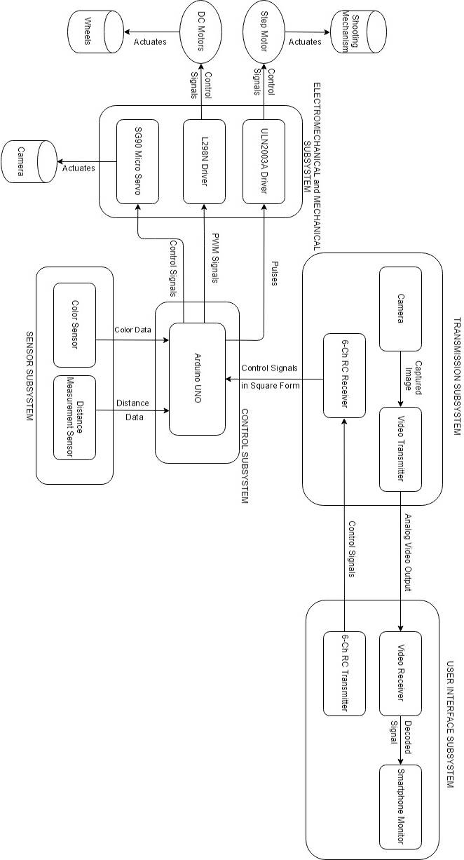

*Figure 1: Overall description of the system with a block diagram including sub-system interaction and interfaces*

The system is composed of five subsystems that are Transmission Subsystem, Mechanical and Electromechanical Subsystem, Control Subsystem, Sensor Subsystem and User Interface Subsystem. The block diagram that shows the connection types and the connections between the subsystems are shown in Figure 1.

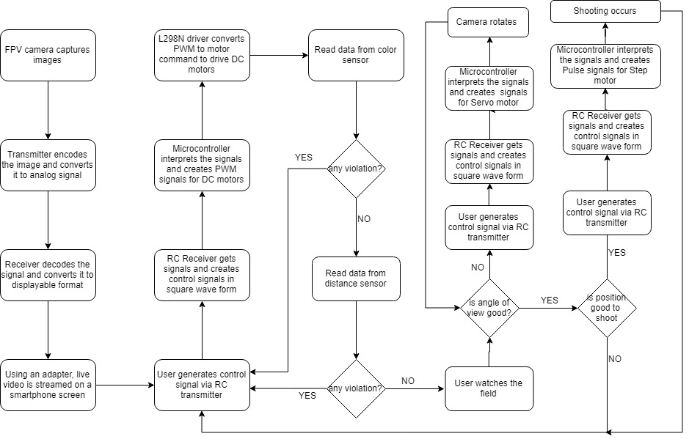

*Figure 2: The main operation flowchart of the system*

The general operation flowchart of the robot is shown in Figure 2. Transmission subsystem is composed of camera, video transmitter, and RC Receiver. Camera captures images and send them to transmitter. Transmitter creates analog video output and sends it to user interface subsystem. RC receiver is used to get actuator signals from user interface subsystem to control the robot. User interface subsystem has video receiver, smartphone screen, and RC transmitter. Receiver gets analog video input from transmission subsystem and decodes it. Then it sends this decoded signals to screen in displayable format. Using and adapter between them, smartphone screen displays live video stream that comes from robot. RC transmitter here is utilized to send actuator signals to transmission subsystem to control robot.

Control subsystem is the brain of all system and it has Arduino as the controller. Arduino reads sensor data from sensor subsystem and evaluates them for future actions. It gets control signals in square form from transmission subsystem. The controller evaluates these signals to move robot. Arduino creates pulses for step motor driver to stimulate shooting mechanism, PWM signals for DC motor driver to actuate DC motors, and control signal for servo motor to rotate camera.

Sensor subsystem contains color sensor and distance measurement sensor. Color sensor is used for line detection, and distance measurement sensor is utilized in order not to hit walls.

Electromechanical and mechanical subsystem consist of motor drivers and motor. Step motor driver gets pulses from controller and creates control signal to drive step motor. DC motor driver converts PWM signals to control signal to drive DC motors, and Micro Servo directly takes control signals from Arduino to move camera. Also 3D drawing of the final expected product is shown in Figure 3.

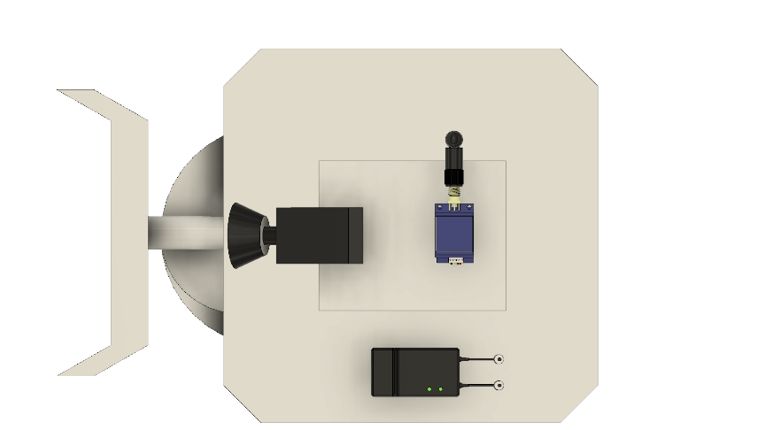 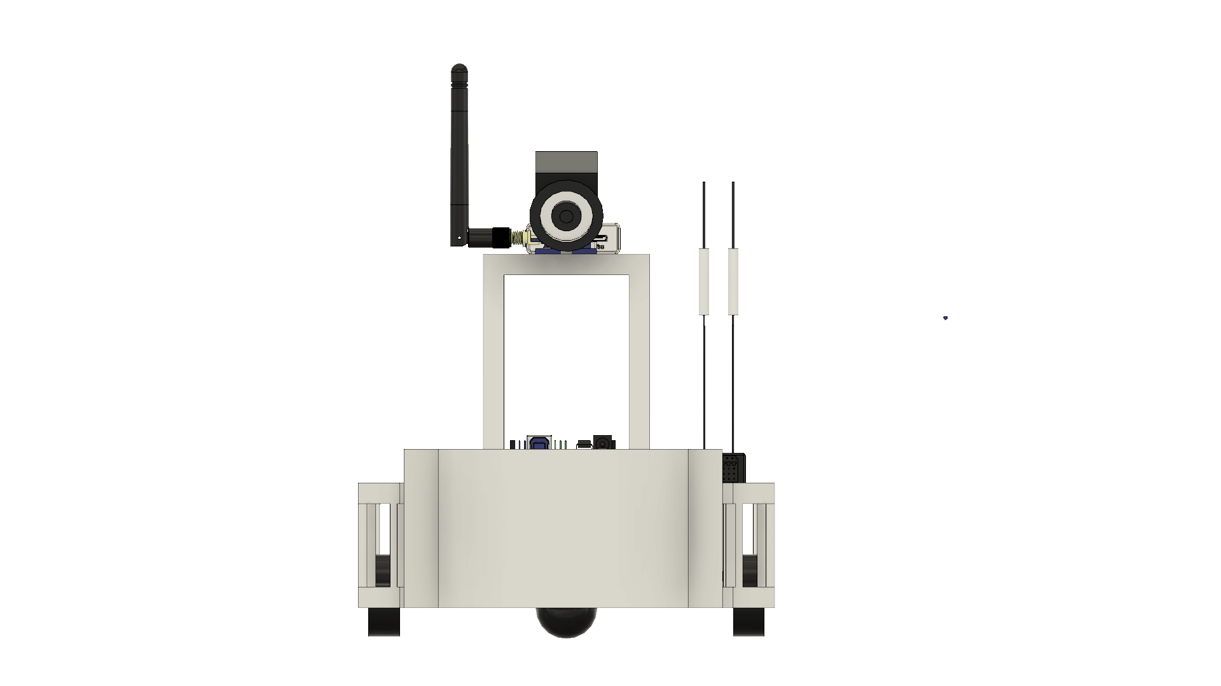

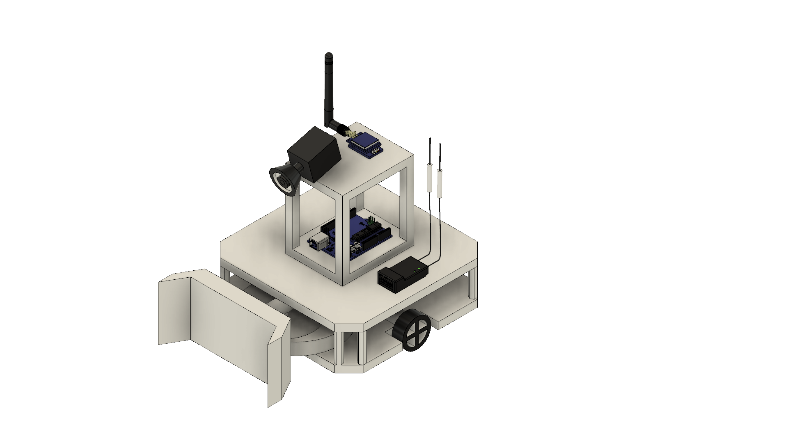 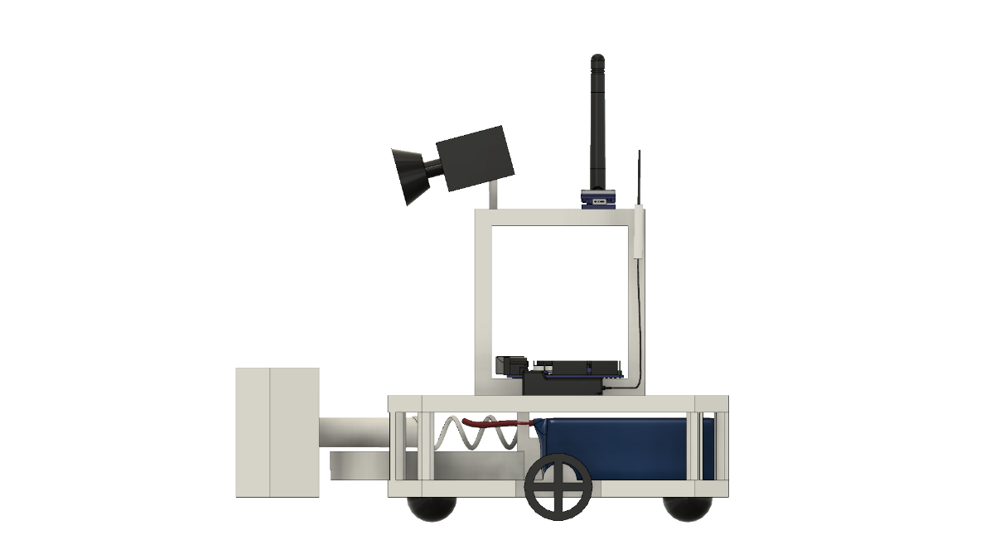

*Figure 3: Overall description of the system with a block diagram including sub-system interaction and interfaces*

## TRANSMISSION SUBSYSTEM

As mentioned before, the operator will control the robot from a distance up to at least 30 meters. Therefore, the operator will monitor the field by camera mounted on the robot. This requires live video stream with enough resolution and low latency for proper operation. for live video stream FPV camera set is used. An FPV camera set is composed of a camera, an analog video transmitter with antenna, and a receiver. Since, the FPV cameras work on analogue video, their resolution is measured in TV lines or TVL rather than pixels. There are some options for TVL such as 420, 480, 600, 800 and 1000. Latency is another factor, which highly depends on both the distance and the quality of the transmitted video. It is usually around 50ms, which is ideal for our project. The transmitter basically processes the image that is captured by the camera and encode this data into an analog signal with a high frequency.

Considering the obstacles that will be put on the area, 5.8 GHz is used for our project to transmit live video. The receiver decodes the signal that is radiated by the transmitter and convert this data into a displayable format. After this conversion, a screen is used to convert the data into a video. A smartphone will be used as the screen. We utilize an adapter between receiver and smartphone. One of the most important specification of the video transmission is the transmitter output power. The transmitter output should be powerful enough so that the video signal can penetrate through walls up to 30 meters. However, it should be at the minimum power specification so that it will not cause a lot interference when reflected from the walls, it will not be unnecessarily expensive, and it will not cause interference for the other teams that might be using a similar set-up.

The transmitter also has many channels in the bandwidth to choose from in order to differentiate the video signal from the signals of other teams. In order to meet the requirements about the range, we can increase the transmitter output power. In theory, in order to double the range, the transmitter output power should be quadrupled since the power is dissipated in other directions from the target direction.[1] However, the range dependence on the transmission power will even be less in practice due to noise and attenuation in all directions , and also increasing the transmitter output power may cause other issues such as overheating of the transmitter module, interfering with other teams and multipath interference caused by the waves reflecting from the obstacles. In order to solve the multipath interference problem, circularly polarized waves are utilized in the transmission.

The video receiver is also a very important factor in the video transmission system. A good receiver has a high sensitivity of signal power. Furthermore, diversity type receiver will be used for the continuity of the transmission since a diversity type receiver has two receiver modules inside. The two receiver modules have separate antenna inputs and the outputs of the receivers are compared according to the received signal strength [2]. The output of the receiver modules which has the greater strength is connected to the output of the overall circuit which feeds into the monitor. The operation principle of a diversity receiver is shown in Figure 4.

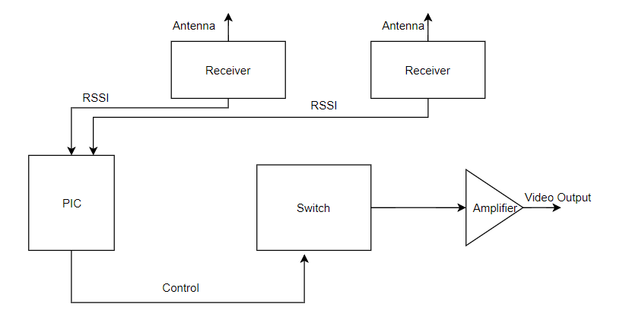

*Figure 4: The block diagram of a diversity receiver.*

Even though the diversity receiver system seems very sound in the operation, it has some flaws such as when the input antenna is changed, there might be a cut in the video for a short duration and the phase difference between the signals received from two antennas since there is a finite distance between the antennae. However, these issues do not cause much of a problem for the overall operation since the speed of operation is negligibly small compared to the magnitude of these problems.

The other important parameter of the video transmission system is the antennae namely, the antenna of the transmitter and the antennae of the receiver. We are using circularly polarized antenna in the system since the polarization direction changes when a circularly polarized electromagnetic wave reflects from an object. The antennae on both the transmitter and receiver are of the same polarization direction that is right hand circularly polarized (RHCP) or left hand circularly polarized(LHCP) so that the wave portion that reflects from an object does not cause an interference since the antenna ignores a wave with another polarization direction. Furthermore, the antenna on the transmitter is of omni-directional type giving equal amount of gain in all directions since the robot will move in different directions and the wave will propagate from different directions. The advantage of using a diversity receiver comes out at this point since we have the capability of using two antennae on the receiver. We use one omnidirectional antenna and one directional antenna with a relatively high gain in order to have gain in all directions and a high gain in direction to increase the gain in that direction [3]. The radiation patterns of an omni-directional antenna and a directional antenna are shown in Figure 5 and in Figure 6, respectively.

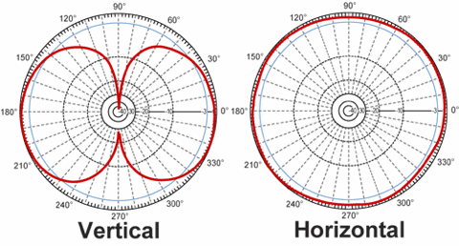

**Figure 5: The radiation pattern of an omni-directional antenna.**

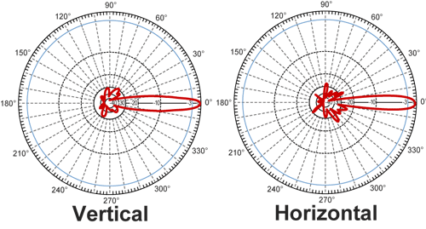

*Figure 6: The radiation pattern of a directional antenna.*

## Electromechanical & Mechanical Subsystem

Electromechanical subsystem is composed of motors and motor drivers. Basically, it is responsible for moving parts of the robot. For instance, movement of the overall chassis, alignment of camera on board according to position of the robot and shooting mechanism control and movement.

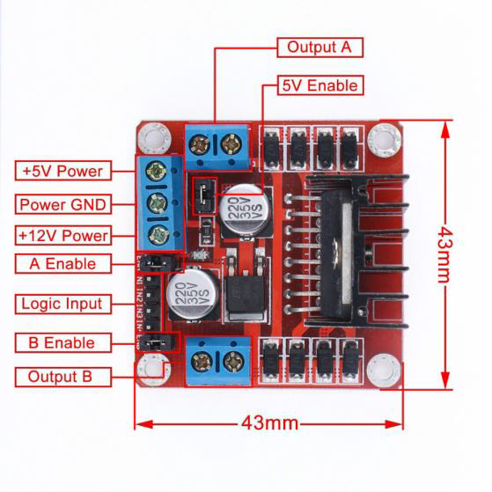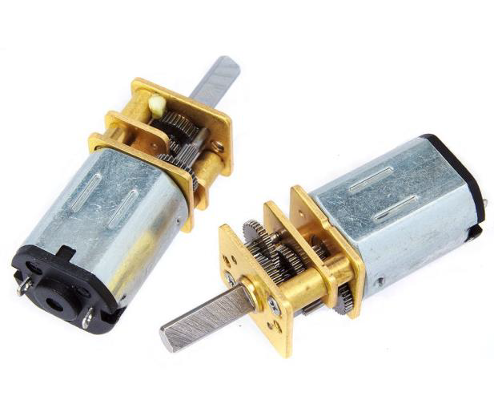

*Figure 7: L298N motor driver and DC motor*

We are going to use DC Brushed motors and L298N motor driver (H- Bridge). These components are commonly used for this purpose and easy to use and they are illustrated in Figure 7. DC motors are operating at 6V and 350 rpm in the free-run speed and works with 60mA continuous current. The maximum forcing current for the motors are 1.3A and the maximum torque to be obtained is 1.8 kg-cm [4]. L298N is used for driving these 2 DC motors synchronously. It is suitable for our project with the specifications that it has current capacity for each motor up to 2A and 6V-15V motor driving capability. It also has lots of analog and digital I/O ports which will be connected to controller via jumper cables easily.

In the main chassis movement, there are two DC motors, two wheels, one free turning wheel and one DC motor driver. Two wheels connected to DC motors are implemented to the left and right sides of the robot. Free turning wheel is implemented to the front side of the robot. The movements will be achieved by the differential wheels.

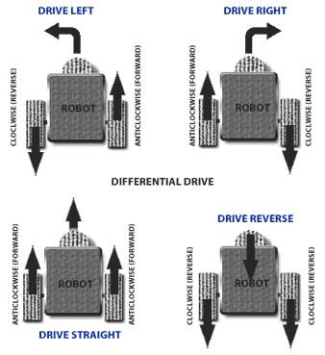

*Figure 8: Robot movements with 2 Motors*

Operation principle of differential wheels are simple. If both the wheels are driven in the same direction and speed, the robot will go in a straight line. If both wheels are turned with equal speed in opposite directions, as is clear from the diagram shown in Figure 8, the robot will rotate about the central point of the axis [5]. While turning the robot to one direction, either one motor is driven through forward and other to backward or both in the same direction with different speeds. Since the direction of the robot is dependent on the rate and direction of rotation of the two driven wheels, these quantities should be sensed and controlled precisely.

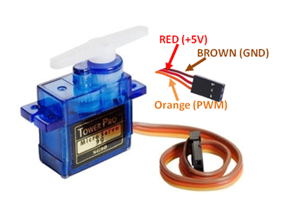

*Figure 9: TowerPro SG90 Micro DC Servo Motor*

Moreover, we are using servo motor that is connected to camera the on the robot so that we can move the camera to have a better sight. This also plays very important role for the project because we must have as better sight as possible to make proper movements with the robot in order to reach the ball and act on time. TowerPro SG90 Micro Servo will be used for these purposes. It is a low-cost plastic gear RC servo with 1.80 kg.cm holding torque (at 4.8V). The servo is illustrated in Figure 9.

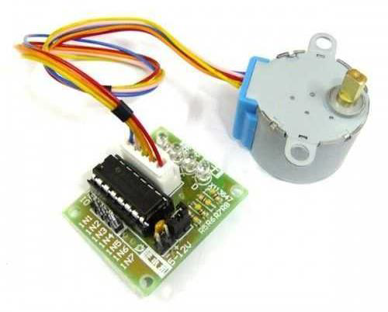

*Figure 10: 28BYJ-48 Reducer Step Motor and ULN2003A Step Motor Driver*

In the spring system, we will use a Step Motor for triggering system as mentioned in shooting mechanism subsystem part. We will use 28BYJ-48 reducer step motor and ULN2003A step motor driver. This motor is cheaper and torque and current ratings are suitable for our operation. The motor and driver is illustrated in Figure 10**.**

## Shooting Mechanism

A shooting mechanism that employs a spring can be very powerful because, depending on aptly selected parameters, a spring can store inordinate amounts of energy. A system such as this would therefore be able to shoot the ball with high velocity. Moreover, the number of shots that can be made by virtue of this setup is almost unlimited because it is powered by a battery. On the other hand of the spectrum, however, the system also has its setbacks, it may be difficult to implement it mechanically and takes a while to reload. When the power consumption is considered, these are the problems can be solved easily rather than energy problem. As a result, a mechanical shooting mechanism, namely spring-based shooting mechanism, will be implemented onto the robot for these reasons. The Figure 12 below depicts the general structure of a spring-based shooting mechanism

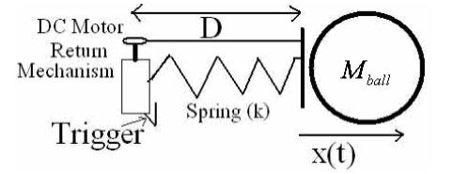

*Figure 12: Spring based shooting mechanism working principle*

There will be a triggering component, a DC motor, to compress the spring and store energy onto it mechanically. When the triggering command come by user, it starts to operate. After the required turn is made on motor, it suddenly releases the spring and as a result shooting is achieved. Shooting power and velocity of the ball will be tested and the mechanism can be optimized easily by changing either the position of the motor and rails or the length and material of the spring accordingly. There are different methods for spring compression and shooting mechanism.

Starting with a spiral shaped mechanism, a spring is compressed with the help of rotation in spiral mechanism by using a motor. As the spiral rotates with the step motor, the spring is compressed until the spiral completes full 360-degree rotation. When it completes its rotation, the spring is released, and the force is created. This option is depicted in Figure 13.

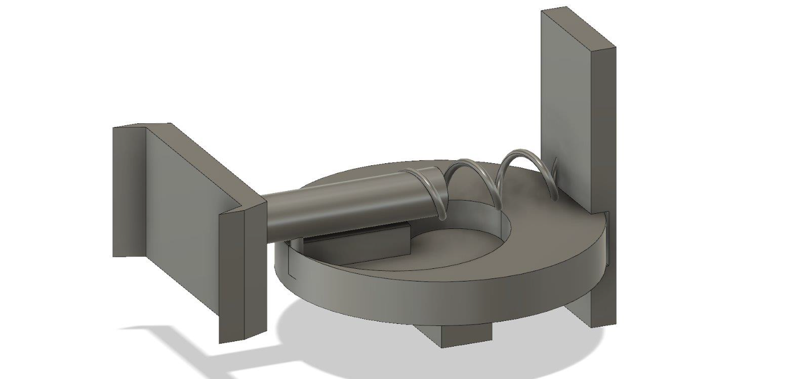

*Figure 13: 3D model of shooting mechanism*

It should be noted that for spring compression, different types of mechanical solutions can be implemented using the very same idea, i.e. compressing the spring and releasing the shot.

## Control Subsystem

Control subsystem consists of two parts. One is remote control device and the other one is microcontroller. For the remote-control device, we will be using 6-Ch RC Transmitter & Receiver. We are planning to use 2 channels for controlling the robot movements, 1 channel for adjusting the camera angle, and the last channel for shooting. This device quite practical and convenient for the project. It is in low power consumption for durable using. It also has high receiving sensitivity.

For the on-board control purposes, the use of a microcontroller is inevitable. In the market, there are so many different microcontroller boards with different properties. Due to its simplicity and popularity, we are planning to use Arduino UNO. It has clock frequency of 16MHz, variable input voltage between 7 and 12V, analog input pins and PWM output pins, apart from the digital GPIO pins. The Arduino UNO is shown in Figure 14.

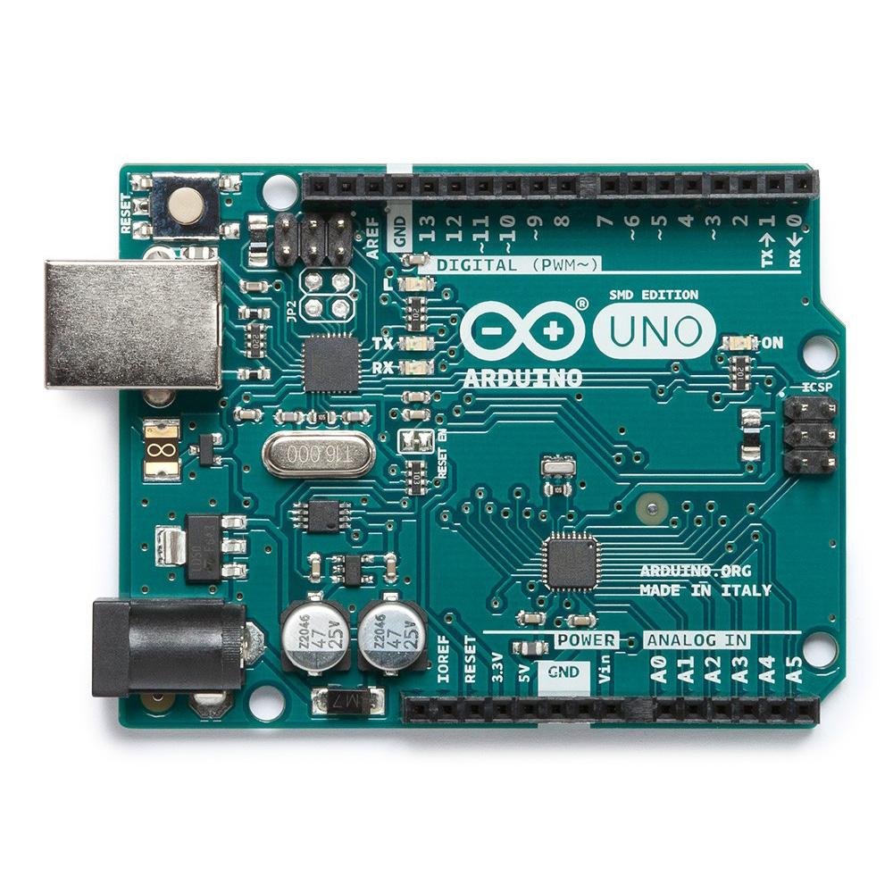

*Figure 14: The Arduino UNO with the GPIO pins soldered to the male headers*

The main mission of the Arduino is to get the signal (sent by the user through RC transmitter) from the receiver and generate the required motor commands according to instructions. These instructions will come from the 4 channels of the RC transmitter and delivered to the Arduino via receiver in the form of a square wave. These 4 signals have the period of 20ms and their duty cycle vary depending on the position of the joysticks in the RC transmitter. When the joystick is at the maximum position, the transmitted signal has the ON time of 2ms, corresponding to 10% duty cycle. At the minimum position, the ON time is 1ms resulting in the duty cycle of 5%. Thus, by calculating the ON time of the incoming 4 signals, the Arduino will generate the desired motor commands. These signals will be delivered to the motors accordingly. In the case of the main DC motors, which are responsible for the positioning of the robot, the motor command will change instantaneously in analog manner according to the incoming signals. This action is valid for the Servo motor as well, the purpose of which is to rotate the FPV camera. However, in case of the shooting action, since the motor inside the shooting mechanism does not need to turn continuously, the motor command will be generated for some period, according to the digital shooting signal.

To sum up, control subsystem’s function is that RC Transmitter sends the signals to the receiver that is on the robot, then the receiver generates pulses and sends them to the microcontroller and finally microcontroller interprets these signals and generate commands for the robot. At the end, the robot moves according to the instruction that is sent by the operator and shoots the ball whenever the shoot button is pressed on the RC transmitter.

## Sensor Subsystem

Since the robot is expected to not cross the lines, we will be using a color sensor. The color sensor product provides RGB (Red, Green, Blue) light sensors for precise color measurement, determination, and discrimination. We are going to use the color sensor to identify center-line and goal lines marked by “masking tape” because the robot is forbidden to pass on center-line and get behind the goal line.

We will include distance measurement sensor which is HCSR-04. It is the most well-known and available distance measurement sensor. This ultrasonic sensor has a 3mm sensitivity and 2-400 cm range. It can be used in distance measuring, radar and robot applications. We are planning to use this sensor to measure distance between the robot and the walls so that the robot does not hit the wall. Using the data coming from the sensor, the robot will take action immediately if it gets very close to a wall.

## User Interface Subsystem

In the interaction of the user with the system, we planned to use a controller and monitoring subsystems as user is not allowed to see the playing field with naked eye. The user needs to see the information coming from the robot on a display screen. For this purpose, a smartphone will be used. For now, the receiver in the system generates an AV output and we are using an adapter display the video on the smartphone screen. This setup is tested several times and it is working really well. By this way, anyone will be able to play the game anywhere.

For the control of the robot, the user should be able to have a device to steer the robot and issue commands. For this purpose, RC controller will be used as mentioned in the Control subsystem part. RC controller is reliable and user friendly since there will be control buttons for steering of the robot and the camera and shooting requiring different channels for each control. The experiment with an RC controller was performed along with the transmission subsystem in different conditions and the results are even better than the video transmission. The RC controller can send commands with little to no delay up to 100 meters with obstacles between the robot and the user.

# REQUIREMENTS

## Mechanical Subsystem:

The mechanical subsystem not only entails a sturdy system but also one in which each independent module meets specific desired specifications, these modules then work in tandem to ensure smooth operation of the entire system. Firstly, The FPV camera must have a fair vantage point by virtue of which a wide angle of view can be maintained. In addition, the shooting mechanism should be such that it maintains a hardy and strong grip; it should also be in close proximity to the ground in order to ensure that the ball is shot properly.

In a similar vein, the mechanical subsystem must also be assembled such that the motors are positioned far away from the ball. Any module that consumes significant amount of power must also be placed in direct contact with air in order to eliminate the possibility of overheating. Additionally, a well assembled mechanical sub-system would be one in which the transmitter and receiver are not stationed near the battery.

## Electromechanical and Power Subsystem:

The electromechanical subsystem necessitates agility in both the defense and attack modes of the robot. Firstly, the robot should inherently have the ability to rotate about itself, it must also be able to perambulate around the play field in order to align its position according to the position of the opponent and the ball. In addition, the robot is confined and circumscribed to only half of the play field and must be responsive and agile enough to shoot the ball in as minimal a time frame as possible since each player cannot be in possession of the ball for a duration longer than 20 seconds.

## Control Subsystem:

The purpose of the control sub- system is to coordinate and process the multitude of data that emerges from the sensors and the receivers in order to actuate the necessary motor commands for all DC motors. These DC motors are employed in order to control or vary the position of the robot and the viewing angle for the camera. Similarly, the DC motor that the shooting mechanism constitutes should also be controlled whenever the ball must be shot and the relevant signal arrives.

## Sensor Subsystem:

The modules that the sensor subsystem constitutes must be designed so as to ensure that the robot does not cross the midfield line so that the game rules are followed. In order to ensure this, a color sensor, TCS3200, in particular will be employed.

Since the walls are potential impediments, our robot must avoid colliding into them. For this reason, we will use a distance sensor which will be operational for distances up to 20 cm.

## Transmission Subsystem:

This subsystem is the most crucial for the operation of our robot. It entails wireless communication for up to 30metres, notwithstanding the contingency of the placement of obstacles placed in the robot’s pathway. Therefore, the information can be transmitted by virtue of a video, discrete images or processing of image signals. Competitors have been given the leeway to choose their own desired form of transmission; in our case it is video transmission. A limitation exists, however on the nature of the transmission; the use of Wi-Fi protocol, in particular is not permitted. This sub-system also necessitates disparate forms of transmission so that the eventuality of interference between each groups transmission is eliminated.

## User Interface Subsystem:

A user interface system is a requisite for the completion of the project since the user is not permitted to view the play field under any circumstance. The robot can only be viewed via a user interface system. Therefore, the user must be able to view the incoming information on a display screen. In our own, personalized set up, we need a system/ receiver output that is compatible with android phones so that a mere android phone can be employed to view and thereafter control the robot. This module also requires a controller so that the robot may be steered depending on the commands issued. Owing to the fact that a RC Controller is sufficiently reliable, and can issue commands with virtually no delay, for up to 100metres, we have concluded that employing one would be a prudent decision.

# DESIGN MODIFICATIONS

Conceptually, we have not changed any of the design choices in the conceptual design report. For the video transmission sub-system, we are using FPV transmission system and we did the demonstration and the related tests using an FPV system which is affordable in the limited budget. The video on a test robot was successfully sent over the required distance with obstacles and walls in the way and it was displayed successfully on a smartphone. The latency in the video transmission was also measured using a creative and reliable test method which is to take a picture of a timer together with the live video of the timer on the monitor which is mentioned in more detail in the test procedures as shown in Figure X. Therefore, we have not changed the video transmission design moving from the conceptual to critical design.

For the remote control of the robot, an RC transmission system is used and it has been tested in different environments over the required distance and it works successfully. Also, it does not constitute a risk of exceeding the budget even though it is the most expensive component in the overall design.

For the electromechanical sub-system, we are using DC motors for the movement of the robot, servo motor to move the camera and step motor to compress the spring in the shooting mechanism. For continuous movement, DC motors are best in this scale. It was tested under different load conditions and it worked successfully.

We need a precise movement and high torque in the shooting mechanism, thus a step motor is used whose number of steps in one full rotation is known. The step motor is tested with the current shooting mechanism and it faces a few difficulties compressing the spring. However, we are planning to solve this by modifying the shooting mechanism to rotate more easily, change the spring and use one that can be compressed more easily, change the shooting rod or use a more powerful step motor.

The servo motor to rotate the camera is tested and it is successful since a typical servo motor used in small projects is well suited for this kind of precise, fast-response and light rotations.

For the mechanical sub-system, plexiglass is used as the body of the robot since it is low-cost and a strong material wand it is widely used for this kind of robot projects. We are using a spiral like mechanism, which compresses a spring while it is rotating. It works successfully for the most part but it has some issues that will be solved using the above mentioned solution proposals. The spiral mechanism is shown in Figure 13.

# COMPATIBILITY ANALYSIS OF SUB-BLOCKS

In a design, it is not enough to only design every subsystem individually but also to integrate those subsystems together in an overall design and run the whole system. Every sub-block should be compatible with each other and the working of one block should not affect the working of another block. Therefore, we have analyzed every subsystem in terms of their relation with other subsystems.

The mechanical subsystem is directly connected to the electromechanical subsystem i.e. the actuators in the electromechanical subsystem actuates the mechanical subsystem. The servo motor rotates the camera mount, the step motor compresses the spring by rotating the spiral and the DC motors move the whole body by making use of differential drive method. The electromechanical subsystem is connected to power subsystem, control subsystem and transmission subsystem. All the components in the electromechanical subsystem are powered by the power subsystem and they take inputs from the control subsystem. All the inputs to the motors are provided by the user over the transmission subsystem to the control subsystem which controls the movement of the motors. Also, the step motor moves the camera and the output of the video changes with respect to that movement.

The sensor subsystem is connected to power and control subsystem. Sensors are powered by the power subsystem and they feed input to the control subsystem. Transmission subsystem is connected to the control subsystem and user-interface subsystem. All these subsystems are tested together in different combinations and it has been observed that none of them has any effect on the other.

The overall signal interfaces and the connections of the subsystems with each other is illustrated in a block diagram as shown in Figure 1.

# COMPLIANCE WITH THE REQUIREMENTS

After an enumeration of the requirements for the robot, it is imperative to evaluate the degree to which each of these requirements have been met. As cautious and shrewd engineers, we have evaluated each contingency that could go wrong with the design and have taken steps to ensure not only that each condition is fully satisfied but also eliminated questionable and dubious elements that could interfere in the intra - system and be potential pitfalls for us. A case in point is the transmission sub system. Since the robot will be ambulatory, the signal might be lost and therefore, we have taken steps to counteract that eventuality by employing an omni- directional antenna to ensure that the wave is transmitted with the same power in all possible directions, so that no signal loss occurs. Inherently, in antenna systems, the gain and omni direction are at odds with each other and hence there is a trade-off between them; the higher the gain of an antenna, the less likely it is to receive signals from disparate locations and therefore, it will be directed to a single location. In order to counteract this issue, we employed a diversity receiver with a dual antenna and will be using one omni - directional antenna with a low gain and a directional antenna with a high gain, combined. Moreover, for a responsive robot, it is indispensable that our robot be nimble enough to react in time when an action is necessary. Therefore, we installed the camera on top of the robot so it can attain a wide field of view, in addition, it will be able to rotate by virtue of a servo motor.

Within FPV systems too, a trade-off exists, between range and the penetration capability, in terms of the wave frequency; therefore, it is necessary to evaluate what overcoming this issue entails. Since the robot should be operative for up to 30metres and owing to the fact that this is an indoor project, it is necessary to choose a transmitter cautiously. Therefore, after careful deliberation, we have decided to use 5.8 GHz transmitter.

Within the project itself, there are several elements that are potential perils. If we consider interference for example, reflection from objects could cause severe interference, therefore, we make use of an antenna on both the receiver and the transmitter, with the same polarization direction. This method obviates interference.

Power considerations hold a lot of significance and therefore, in each subsystem, we have taken steps to ensure that no module consumes needless power. We were quite wary of our choice for the transmitter since it can consume more power than we need; therefore, we used one that could ensure continuous transmission with low latency. With a defined and circumscribed budget, we have tried to curtail costs as much as possible. By employing a receiver that is compatible with android phones, for instance, we have aptly avoided the need to use computer screens for display purposes since we will be able to display the video on an android phone through the receiver.

# TEST PROCEDURES

We have tested the shooting mechanism by building the prototype system given in Figure 15.

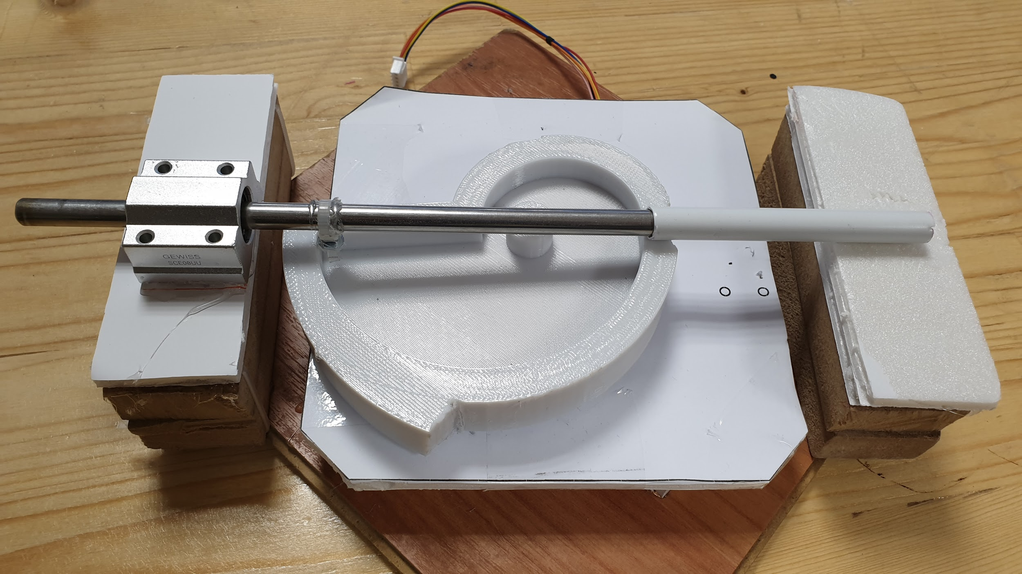

*Figure 15: Test setup designed for shooting mechanism*

We realized that the center of mass is not coaxial with the rotation axis of the step motor shaft. This leaded system to rotate with an angle resulting in very high friction. Due to the high friction, the spiral stuck and did not complete one full rotation properly. Another difficulty with this configuration is that the rod is rotating around its coaxial axis while trying to slide in the path. These problems are solved by designing a new spiral, whose 3D model is illustrated in Figure 16.

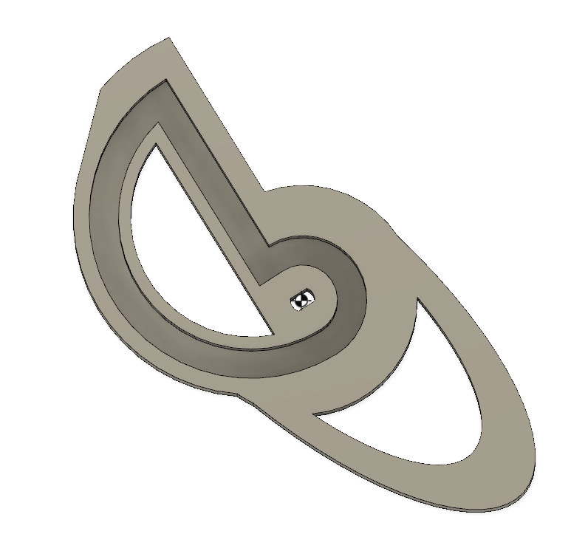

*Figure 16: New spiral designed for shooting mechanism*

In this model, the weight is reduced ⅓ of the previous spiral. Also, the dimensions of the mechanism are decreased. It helps us to implement shooting mechanism into the chassis easily. Furthermore, to prevent rod rotating its own axis as mentioned above, an extra inner wall is added. It can be also seen in Figure 16; the center of mass is adjusted by adding elliptically shaped extra material.

For the testing of the transmission subsystem, we prepared a number of test mechanisms to characterize the transmission in different specifications such as range, latency and interference. In order to test the latency of the transmission, we took a photograph of a timer together with the live video stream of the timer and measured the difference between the times as shown in Figure 17. In the shown setup, the transmitter and the receiver were very close to each other and there were no obstructions between them, and the latency was measured to be 80ms which is negligible since the reaction time of a human is 0.25s for a visual stimulus. We tested the latency when the transmitter and the receiver are as far away from each other as 20m and we observed that the increase in the latency with distance is almost negligible since it did not even reach 100ms. We could not test the latency with walls between the transmitter and receiver using this setup, however, we tested it using the reaction time of a human and we could not distinguish a difference between the real timer and the video of the timer. Therefore, we can safely assume that the latency in video transmission will not affect the health of the operation.

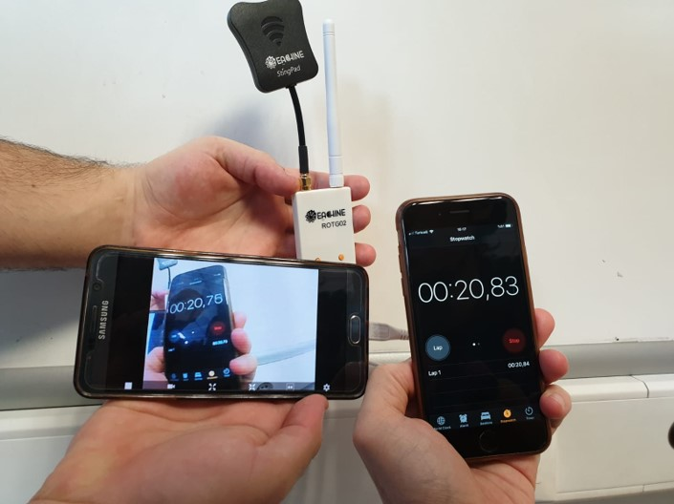

*Figure 17: The test setup to measure the video stream latency*

For testing the range of the video transmission, we experimented in different environments and over different distances. The upper limit of the video transmission range in line of sight could not be found exactly because it is much longer than 30m. However, when there are walls and obstacles between the transmitter and receiver, the range goes up to 40m with bad quality video. Furthermore, we tested when the transmitter was turned around itself and the result is the same since the antenna on the transmitter is an omni-directional antenna. We will also test the video transmission on the robot itself when the chassis of the robot is built. Therefore, we can safely assume that there will be no problem with video transmission due to distance.

For testing the interference within the system and with other teams, we performed the experiments inside a reflective environment. We observed very little drop in the video quality due to multipath interference. However, the effect of the multipath interference is kept at minimum by making use of circularly polarized waves. Also, we ran the system while another transmission system was working in the same environment. We observed no interference with the other system since we use multi-channel transmission system and we are safe as long as the channels are different from each other. We will also test the system when there are more than 2 systems working at the same time in the future to guarantee that it will work in a match. Therefore, we can safely assume that there will be no problem with the video transmission due to interference.

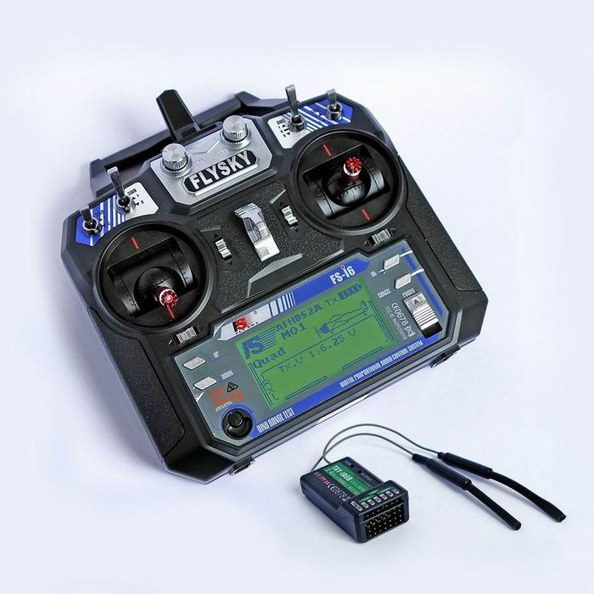

*Figure 18: The test setup to measure the video stream latency*

The experiment with an RC controller is performed along with the transmission subsystem in different conditions and the results are even better than the video transmission. The RC controller is able to send commands with little to no delay up to 100 meters with obstacles between the robot and the user. It is tested by using a commercially available RC transmitter of FlySky-i6 which is illustrated in Figure 18.

# RESOURCE MANAGEMENT

## Cost Analysis

Budget analysis is made considering the optimal price over quality ratio. For component selection, we obtained some products and experimented them under different conditions. Then, we finalized the components with best compromises. The budget analysis is shown in Table 1.

|  |  |
| --- | --- |
| COMPONENT | PRICE |
| Video Transmitter | 13$ |
| Video Receiver | 19$ |
| FPV Camera | 25$ |
| RC Controller | 46.5$ |
| Battery | 25$ |
| DC Motor (x2) | 10$ |
| Servo Motor | 5$ |
| Stepper Motor & Driver | 2.5$ |
| Ultrasonic Distance Sensor (x2) | 2$ |
| Chassis (Screws, Plexiglass, 3D Material, Motor Mount, Spacer, Cables) | 13$ |
| Shooting Mechanism (Rod, Spring, Bearing, Rails, 3D Material) | 7$ |
| Motor Driver | 2$ |
| Wheels (x2) | 2.25$ |
| Arduino | 2$ |
| Voltage Regulator | 3$ |
| Ball | 1.5$ |
| Walls | 5$ |
| Caster Wheel | 2$ |
| TOTAL | **187$** |

*Table 1: Budget analysis showing the price of every component.*

## Power Analysis

For power supply, we use LiPo battery. LiPo battery is the most convenient one because it has higher energy/weight rate, energy/volume rate, high voltage, and long lifespan. It also keeps for long because of the low self-discharging rate and its discharge capacity is 5200mAh which is enough for our operation.

In shooting mechanism, stepper motor works when the user gives operate command. The stepper motor draws 300mA and works under 5V. The power consumption is (300mA)2/5V = 0.45W per shot.

In camera movement, the servo motor draws 70 mA in average under 6V. The power consumption is 6V*0.07 A= 0.42 W. Note that this is not the average value because servo will be operating when it is needed to move the camera.

In transmission, P (Transmitter (@ 600mW output power)) =3.5W, P(Camera)=1W, P(Receiver)=1W. These values are taken from the datasheets of corresponding components.

In movement subsystem, each motor draws 0.5 A in average under 6V when they are in operation. The DC motors work in 80% of the time. 6 V* 0.5 A*0.8*2= 4.8 W.

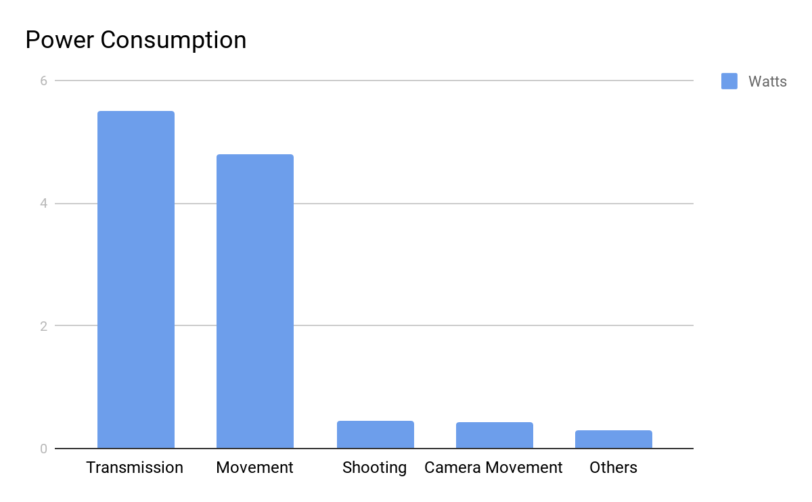

*Figure 19: Power consumption diagram of the whole system*

## Gantt Chart

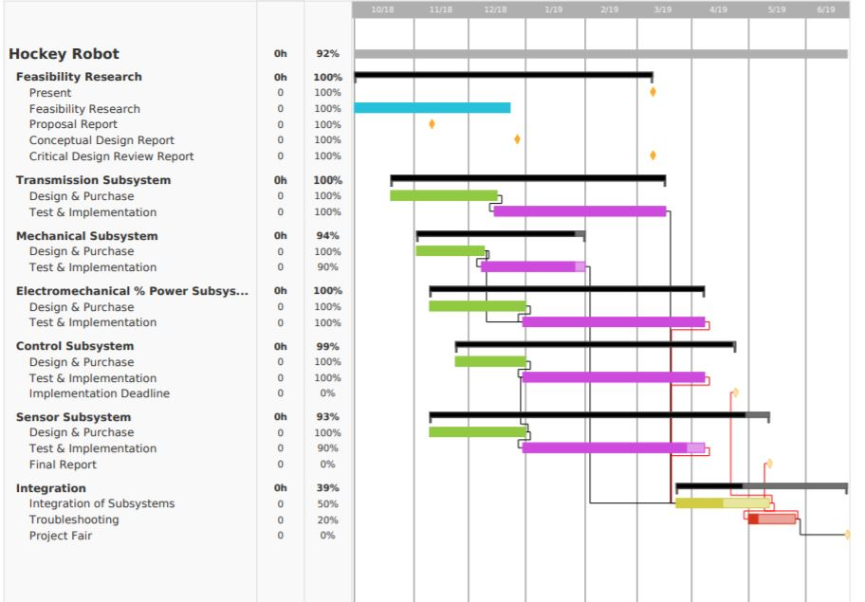

*Figure 20: Planned Gantt Chart*

The work done so far and future work plan is stated in Figure 20.

# CONCLUSION

In this report, we have outlined the overall critical design in a top-down fashion in detail. We have provided system and subsystem block diagrams, flowcharts and 3D drawings to support the design choices. We have finalized every design choice and provided justifications for every selection. We have provided the system and subsystem level requirements and the compliance of every subsystem to these requirements. We have explained test procedures and listed test results for every subsystem and some combination of subsystems. We have provided test plans for the future to guarantee the working of the overall system. We have analyzed the compatibility of subsystems with each other in the overall system and provided the relations of every subsystem with others. We have analyzed the overall system in terms of cost, power and time schedule. We have prepared a detailed cost analysis showing the price of every component, a detailed power budget showing the power consumption of every component and the comparison of total power consumption with the battery capacity and a Gantt chart showing the progress of every subsystem together with the overall system and where we are now. On paper, every subsystem within the overall design works individually and together. In practice, although some setbacks related to mechanical systems are present at the moment, we will successfully fix every problem and integrate the overall system in the end. Finally, we feel ready for building the overall system and for demonstrating our design.